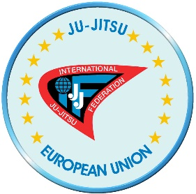

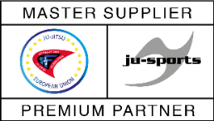

Strategy “10-5-30”
of the Ju-Jitsu European Union

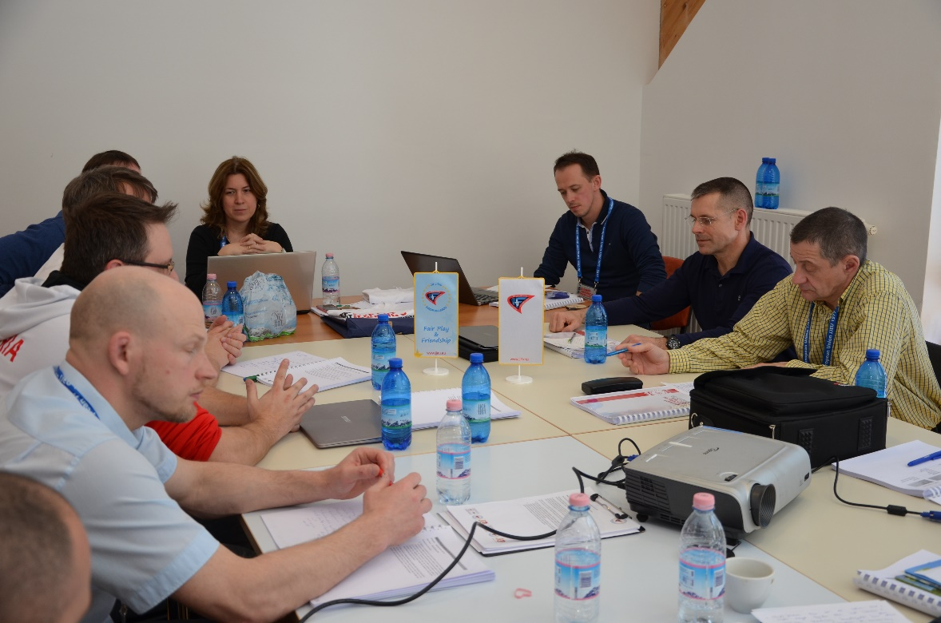
Photo from the Expert Technical Meeting – Event One, in Slovenia, 10 – 12 March 2017.

(DRAFT, VERSION 1.0)

Proposal from the JJEU Board for the delegates of the JJEU General Assembly
Banja Luka, Bosnia and Herzegovina, 2 June 2017

“This is a story about a journey (vision).
We are allowed to take only 10 things (values) that will help us solve the problems and challenges ahead. The path to is not easy nor straight.
We will have to cross five different types of terrain (strategic goals): ocean (knowledge), forest (membership), desert (visibility), tundra (governance) and mountains (performance).
We cannot be certain, but we believe that we can reach the end of the path by making 30 stops along the way. Sometimes it will take more time and effort to get there as initially planned, sometimes we might have to take different detours, but it is important that we have a general direction where do we want to go.”

STRATEGY

OF THE JU-JITSU EUROPEAN UNION

2017 – 2024

PREAMBLE 3
MISSION 3
VISION 3
I. VALUES 4
I.1 Fair Play 4
I.2 Tradition 4
I.3 Sport and Fun 4
I.4 Integrity 4
I.5 Autonomy and Accountability 4
I.6 Transparency 5
I.7 Democracy, Participation and Inclusivity 5
I.8 Learning, adopting, developing 5
I.9 Sustainability and protection of environment 5
I.10 Volunteerism 5
II. GOALS 6
II.1 Membership 6
II.2 Visibility 6
II.3 Performance 6
II.4 Governance 7
II.5 Knowledge 7
III. STRATEGIC ACTIONS 8
III.1 Membership 9
III.2 Visibility 10
III.3 Performance 11
III.4 Governance 12
III.5 Knowledge 14
IV. Follow up 16
V. Registration of changes 16

PREAMBLE
The Ju-Jitsu European Union (JJEU) was established on 29th October 1977 (initially named the European Ju-Jitsu Federation) with the purpose of development of ju-Jitsu in Europe and worldwide. The founding members declared their vision of cooperation of different ju-jitsu organisations under one umbrella.
In 2017 the JJEU General Assembly, as the highest authority within the organisation, recognised the need to update the mission, values and vision and to set the bolder path for the future development of ju-jitsu in the Europe and worldwide.
This document is second strategic documents of the JJEU for the period from 2017 to 2024, pursuing the RESOLUTION ON THE MISSION, VALUES AND VISION OF THE JU-JITSU EUROPEAN UNION 2017 – 2024, approved by the JJEU General Assembly in Banja Luka, 2 June 2017.
The follow up actions by the Board and Committees will create detailed action plan, with operators, deadlines, milestones and reports to be prepared for each action and objective.
Strategy is important guideline of our work but also live and development content, subject to corrections.

MISSION
The mission of the Ju-Jitsu European Union is to develop a spirit of friendship, fair play, peace and understanding among Ju-Jitsu organisations all over the continent.
Ju-Jitsu European Union is, within its capabilities, assisting, supporting and helping developing ju-jitsu worldwide with knowledge, expertise and personal.
Ju-Jitsu European Union assists, coordinates, supports and develops activities of national federations, regional organisations and clubs in compliance with the JJIF framework and this Statute.

VISION
With the respect to the mission and values, the Ju-Jitsu European Union commits to achieve the goal of recognition of ju-jitsu by the International Olympic Committee (IOC) and participation at the European Games, which would in effect mean the recognition by the European Olympic Committee (EOC).

VALUES (10)
Ju-Jitsu European Union’s values reflect 40 years of history and development, the awareness of a need for continued education and development, but taking into account the principles and values of Olympism. The following values determine the way we want to achieve our goals.

I.1 Fair Play
Fair play was not limited only to sport, but has been one the fundamental principles of overall work in the ju-jitsu community. Ju-Jitsu European Union shall continue to raise awareness of fair play in the fields of fair competition, respect, friendship, team spirit, equality, sport without doping, respect for written and unwritten rules such as integrity, solidarity, tolerance, care, excellence and joy, are the building blocks of fair play that can be experienced and learnt both on and off the field.
In a broader context, fair play also includes highest respect for anti-doping regulations.

I.2 Tradition
The Ju-Jitsu European Union is a relatively young organisation that keeps evolving. Nevertheless, it should reflect traditional values of martial arts like respect, politeness, courage, honesty, loyalty self-control and honour.

I.3 Sport and Fun
The Ju-jitsu European Union strives to create an atmosphere of fun and friendship. Fun and friendship surpass sport and make ju-jitsu a lifestyle. Ju-jitsu is highly competitive sports, but it should also be available for people of all ages and adjusted to their personal goals, which can range from self-defence to recreation. Only fun and friendship will keep different generations involved in ju-jitsu in various roles (e.g. athletes, trainers, officials, mentors).

I.4 Integrity
All members of the Ju-Jitsu European Union (athletes, referees, officials, volunteers and other stakeholders) shall embrace the code of ethics as a fundamental principle of conduct. The Ju-Jitsu European Union enables, supports and encourages ethically correct behaviour as a positive aspect of internal organisation life.
The Code of Conduct sets high standards of ethical behaviour also for officials and decision makers.

I.5 Autonomy and Accountability
The Ju-Jitsu European Union is working autonomous within the limits of the Statutes.
The Ju-Jitsu European Union carries out its duties on behalf and in the best interest of member federations, athletes, referees, officials, volunteers and other stakeholders. The representatives of member federations and officials of the Union should be able to execute their rights and their duties free from any outside influence and in accordance with the principles of good governance.
The organisation of the Ju-Jitsu European Union reflects clear division of authority (separation of powers) with clear allocation of responsibilities, competences and tasks. Oversight of the decision-making and executive bodies is fundamental to ensure that powers are exercised appropriately and in line with the objectives and duties. This way the organisation is reflecting the accountability of the Committees to the Board and the Board to the General Assembly.

I.6 Transparency
In accordance with the Statutes, financial statements (prepared in compliance with the laws and the accounting standards) shall be disclosed to representatives of member federations and other stakeholders whenever possible. The relevant financial information shall be part of an annual report to the General Assembly.
The decision-making process and the criteria on which decisions are based shall be clear, open, communicated to member federations and adhered to the basic principles of good governance, especially in the nomination, appointment and elections process.

I.7 Democracy, Participation and Inclusivity
The Ju-Jitsu European Union is a non-political and non-profit organization, which does not differentiate or discriminate countries, member federations or individuals for reasons of race, religion, colour, gender, sexual orientation, religion or political opinion.
Minimum democratic standards are installed within Statutes any by-laws with clear procedural rules. The decision-making process and structure of the Ju-Jitsu European Union is reflecting inclusivity and participation of all stakeholder groups such as athletes, referees etc. This ensures that their voices are heard when it comes to important decisions. This principle also applies to the gender equality.

I.8 Learning, adopting, developing
The Ju-Jitsu European Union is a learning organisation, recognizing the need to adjust, innovate and improve. The Ju-Jitsu European Union emphasize the importance of education as an on-going process, embracing best practices, exchanging information and ideas, learning from mistakes and encouraging creative environment.

I.9 Sustainability and protection of environment
Considering the aspects of sustainable development and the protection of the environment, the Ju-Jitsu European Union will contribute to healthy and clean environment, in particular at the ju-jitsu events by implementing modern technologies and paper-free organisation solutions.

I.10 Volunteerism
It is not possible to achieve goals of the Ju-jitsu European Union without volunteers engaged in the task of the Union at all stages and at all times. Work of the volunteers who provide their time and skills for the benefit of development of ju-jitsu should be highly respected and appreciated. As such volunteerism represents the cornerstone of progress of the Ju-jitsu European Union.

GOALS (5)

II.1 Membership
The main goal is to involve more people at all stages and levels, which includes enlargement of the Ju-jitsu European Union in terms of new member federations, increasing number of participants at the Union’s events, develop programmes that assist member federations to increase number of clubs and obtain and retain new members.

II.2 Visibility
Membership is closely related to improved visibility and recognition of ju-jitsu as a highly competitive sport, effective self-defence, a useful tool for security services and active way of life. Ju-jitsu has to become a brand that will attract new members, sponsors and media. The Union shall use public relations and marketing tools, especially social media to attain such goals.

II.3 Performance
Ju-jitsu athletes are one of the most versatile martial artists. The Ju-jitsu European Union will act to raise overall level of performance of athletes by monitoring their results, facilitating training opportunities, assuring high quality of international competition, insisting on fair-play and anti-doping, developing programmes for trainers as well as sharing information and best practices in the field of sport science, medicine and practice.

II.4 Governance
The Ju-jitsu European Union shall provide effective leadership and manage the organisation as well as relations in the ju-jitsu community in Europe. The Ju-jitsu European Union shall search for inclusive and transparent ways of representation of interests of member federations and implementation of the goals of the Union. The Ju-jitsu European Union shall offer operational support at all levels of implementation of activities.
Part of the good governance of the sport are Fair play, anti-doping, match-fixing issues and other activities to protect sport (and beyond), with aim to preserve high standards which are playing important part of the governance and education.

II.5 Knowledge
The Ju-jitsu European Union will create an environment that will enable individual to realise their potentials as athletes, trainers, technical staff and referees through workshops, training camps, evaluations, standards, improvement of software. The Union will award and recognize the effort of individuals that excel in their field of work.
To achieve worldwide development, the knowledge and experience shall be part of exchange programmes to other continents, continental unions and national organisations, members of the Ju-Jitsu International Federation (JJIF).

STRATEGIC ACTIONS (30)

 | (1) Membership | (2) Visibility | (3) Performance | (4) Governance | (5) Knowledge
1 | Roadmap to membership | New JJEU website | Overhaul ECC system | Organisation code | Standards and handbook for JJEU events
2 | Finding new NF members and facilitating their full accession | Use of social media | European ranking list | Goal orientated financial planning and management | Education programme for Coaches / Officials / Referees
3 | Reactivating existing members – way forward | Promotional video-clips | Training opportunities | Modification of the JJEU Statutes, procedures, structure and committees | Evaluation system of referees
4 | Number of competitors in all disciplines – development of disciplines in existing NF | Internet streaming of large JJEU events | Anti-doping | Benchmarking – learning from other successful sports organisations | Ju-jitsu self-defence and violence prevention programme
5 | Women in ju-jitsu | Media campaigns | Injury prevention and rehabilitation | Partnerships that create new value (sponsors, the EC, sports institutes) | Certified trainer programme (JJEU Academy)
6 | Ju-jitsu for life | JJEU Wall of fame | Development of fitness test battery for ju-jitsu fighters | Increase revenues | Regular referee and coach workshops

III.1 Membership

 | Membership | Description
1 | Roadmap to membership | The JJEU should prepare a short document that should present the federation, advantages, and benefits of becoming a member of this association. The document should also describe a process of becoming a member. The Board should be able to offer some incentives to new members.
2 | Finding new NF members and facilitating their full accession | The Board will identify existing national federations in non-member countries and make an assessment about potential accession. In case that there is no corresponding partner, the JJEU should identify well-recognized club or trainer that could potentially grow to the level of the national federation. The Board should support the effort of the NF to become a member of the national Olympic committee.
3 | Reactivating existing members – way forward | The JJEU will hold meetings with an existing member to reinvigorate the cooperation and activities of the member federation. The Board shall share good practices of getting additional clubs becoming members of the national federation or joining with other federations.
4 | Number of competitors in all disciplines – development of disciplines in existing NF | The Board will facilitate member federations in the development of individual disciplines with the exchange of trainers, invitation to training camps, offering education of referees etc.
5 | Women in ju-jitsu | The JJEU will make effort to increase the share of women in ju-jitsu and retain women athletes as trainers, referees, and officials.
6 | Ju-jitsu for life | The JJEU will together with member federation develop and programs to offer ju-jitsu experience to people of all ages. The JJEU will make effort to find ways to launch ju-jitsu champions for veterans (masters).

III.2 Visibility

 | Visibility | Description
1 | New JJEU website | The Board plans to launch new JJEU website that will improve public image and access to information by the end of 2017
2 | Use of social media | The JJEU will use all possible channel of communication with specific and general public (YouTube channel, Instagram, Facebook…). Official photo webpage can be created enabling members, representatives of media and others to access high quality photos. The aim is to find comprehensive and effective ways of public relations. The Board will look for volunteers that would be prepared to share their time and experience in this field.
3 | Promotional video-clips | Next step in improving visibility of the ju-jitsu community is preparation of content and video materials are one of the best way of doing it (e.g. best actions of the EC).
4 | Internet streaming of large JJEU events | The JJEU will set standards that will require live streaming of large JJEU event. The JJEU will support the national federations is such activities (software, database…).
5 | Media campaigns | Ju-jitsu must get more visibility also in regular media (radio, newspapers and television) for public and specific media orientated in sports and martial arts in particular.  A special project with TV to bring more attention and media coverage to ju-jitsu is in progress. Part of the public visibility is also the level of organisation of the events we would like to promote (respecting the rules, ant doping, prevention against match fixing, behaviour, order and organisation of sport hall, security and safety issues…).
6 | JJEU Wall of fame | JJEU will prepare “wall of fame”, which will include athletes, officials, trainers and other individuals which received JJEU awards or were in other way recognized for their accomplishments in development of ju-jitsu.

III.3 Performance

 | Performance | Description
1 | Overhaul ECC system | The Board already stated activities to find feasible model for international tournaments in Europe in terms of costs, revenues and number of top athletes.
2 | European ranking list | The JJEU will develop European ranking list, which will in the first place serve as promotional tool of athletes and federations, attract more competitors to competitions included in the ranking and offer opportunities for increased visibility.
3 | Training opportunities | Top athletes in all age categories need more training opportunities with partners from other countries. This way the overall level of performance can be raised. Summer and winter training camps, one-day trainings after large JJEU events should be supported.
4 | Anti-doping | Anti-doping education and raising awareness is continues process. Athletes should be able to get access to information about threats of doping at the national federations and the JJEU. At large JJEU events mandatory anti-doping testing should be put in place. Anti-doping is also essential part of fair-play in sport.
5 | Injury prevention and rehabilitation | All national federations should appoint a person responsible for medical matters. Gathering of data is the first part of risk assessment and analysis of injuries. The expert committee shall oversee preparation of results followed by recommendations for injury prevention and rehabilitation.
6 | Development of fitness test battery for ju-jitsu fighters | Following examples of some federations universal test battery should be proposed. The battery defines list of measurements that are taken for each athlete. Some federations carry out testing of all competitors after the competition. Anonymised results can be used for training purposes, medical purposes, academic purposes.

III.4 Governance

 | Governance | Description
1 | Organisation code | The Code of Conduct and Ethics Code should be reflected in everyday practice through the work and behaviour of ju-jitsu officials and other stakeholder. The Code of Conduct shall be binding for all members, stakeholder, participants, staff and volunteers. It shall become a standard and requirement for individuals wishing to play some part in the Ju-Jitsu European Union. A Court of Honour with adequate procedures (or other body) will become part of the structure. Compliance with the Code of Conduct shall be an important method of oversight and accountability.
2 | Goal orientated financial planning and management | Financial management is key toll of reaching strategic goals. The budgets will be goal oriented. The board will prepare financial plan for the next year in timely manner and it shall allocate funds for activities supporting implementation of strategic actions. Necessary adjustments in terms of available funds and pace of spending will be made by closely monitoring expenses and revenues. Transparency of income and spending is basis of good governance. Oversight over the financial management shall be established and access to relevant information made available.
3 | Modification of the JJEU Statutes, procedures, structure and committees | The modifications should contribute to clarity on the proper role, function, responsibilities and objectives of all stakeholders. Decision-making process should be transparent and done by appropriate bodies. Key decisions should be endorsed by members. Changes should install appropriate level of monitoring over progress and oversight over spending of funds and implementation of strategic plan with measurable performance benchmarks. The purpose of modifications is also to simplify procedures and task and include as many stakeholders as possible.
4 | Benchmarking – learning from other successful sports organisations | Learning from others and analysing good practices in the development of sports organisations worldwide can assist the Ju-Jitsu European Union in finding right solutions and learning from experience of others. Open cooperation with other sport federations and entities shall be a principle of work of the Ju-Jitsu European Union when recognised as useful and beneficial to the organisation
5 | Partnerships that create new value (the European Commission, sports institutes) | International partnership is a way of learning procedure but also a part of the development and accepting standards which drives sport worldwide – when applicable to the ju-jitsu. International partners can be a huge value to the philosophy of learning organisation.
6 | Increase revenues | Lack of funds for promotional purposes can be mitigated in several ways. The vicious circle of media – audience – financial means has to be broken. Examples of good practices of other sports should be used. The Ju-Jitsu European Union shall implement best practices in the sport and other organisations to find its own way in better recognition of the sport and the martial arts, including stakeholders with knowledge and preparedness to work and participate. The biggest challenge is not to get partners but how to find and keep a good partner. What makes us interesting? We should use means which are free, social media, crow funding etc

III.5 Knowledge

 | Knowledge | Description
1 | Standards and handbook for JJEU events | The new Organisation Handbook (project started already by the previous Board) shall gather best practices, lessons learned and instructions to create a helpful manual for the organisers of the ju-jitsu events. This way we set high standards of ju-jitsu events and make rules of participation, conduct, rights and obligations clearer to all stakeholders.
2 | Education programme for Coaches / Officials / Referees | Comprehensive education programme should give a basic common programme of knowledge which we find necessary for all stakeholders. Increased level of knowledge, skills and work attitude (by those competences) will improve overall performance and cooperation. Exchange programmes with other continents and continental unions shall increase worldwide development of ju-jitsu.  A history and development of ju-jitsu in Europe and worldwide shall be a part of the curriculum. Fair play, anti-doping, match-fixing issues are playing important part of the governance and education.
3 | Evaluation system of referees | A working group was created as the first step in April 2017 to prepare proposals and solutions for decision makers in the field of referee quality management. The group shall provide ideas and programmes, with short and long-term vision how to give new referees a good education tools, how to join expertise of referees, coaches and athletes in the education program and how to conducts self-assessment and evaluation of the referee work with an aim to give a tool for grading and qualification.
4 | Ju-jitsu self-defence and violence prevention programme | The basic principle of ju-jitsu as a martial art is a self-defence. That part has been not considered with much attention Europe-wide (which can be considered as a missed opportunity) although there are many existing programs in our members. From experience, so far self-defence programs can be offered to special entities (like police) and on the other hand violence prevention programme is a part of “self-defence for all”. The Ju-Jitsu European Union wishes to bring together experience and knowledge from national members to prepare specialised and general (violence prevention) programmes
5 | Certified trainer programme (JJEU Academy) | Cooperation with educational organisations from the field of physical education and sport, combined with a waste knowledge of ju-jitsu as a sport and martial arts, could (by looking at example of the referees) be a beginning of a process of certified trainer programme, recognised in EU. An entity, named as JJEU Academy, can be an umbrella of education programmes from which our members can benefit and become important part of worldwide development and cooperation.
6 | Regular referee and coach workshops | The JJEU will in cooperation with the committees once a year prepare a two or three-day workshop for referees and trainers. Each member state should send at least one referee and one coach to assure sharing of information. Lessons learned from Expert Technical Meeting project (ETM) started in March 2017 in Slovenia as Event One will path a programme of annual and regular expert meetings as a forum for discussion and development.

Follow up

The follow up actions by the Board and Committees will create detailed action plan, with operators, deadlines, milestones and reports to be prepared for each action and objective.
The JJEU Board would like to thank Mr Vitja Gricar and Mr Sergej Bizal from Slovenia for expert assistance and help in preparing the draft document for the Board.

Registration of changes

V.1 Prepared as a draft by the JJEU Board.
V.2 Approved by the General Assembly on 2 June 2017, Banja Luka, Bosnia and Herzegovina as a proposal to continue public discussion among members.

